**CAPSTONE PROJECT -- BUG TRACKING SYSTEM**

**Documentation:**

## ****System Architecture (ASP.NET MVC):****

| **Component** | **Responsibility** |
| --- | --- |
| **Model** | **Represents data (Bug, User, Project) with Entity Framework.** |
| **View (Razor)** | **Renders HTML UI with dynamic data.** |
| **Controller** | **Handles HTTP requests, processes logic, and returns views.** |

**1. Setup -**

### ****Step 1: Create a New ASP.NET MVC Project****

1. **Open Visual Studio → Create a new project.**
2. **Select ASP.NET Core MVC App (Model-View-Controller) and click on Add.**
3. **It will display WebApplication(no)  and click Create.**

### ****Step 2: Create Model class****

1. **Right-click Model → Add → Class.**
2. **Give class name as Bug.cs and click Add**
3. **Give the Class Objects that should be given**

**Step 3: Add the Controller class with BugsController.cs**

1. **Right-click Controllers → Add → Controller.**
2. **Select MVC Controller with Views, using Entity Framework.**
3. **Choose Bug as Model, ApplicationDbContext as Data Context.**

**Step 4: Apply Migration and Run Package Manager Console**:

* **Add-Migration InitialCreate**
* **Update-Database**

**Step 5: In Views Section give HTML for Styling in Index,Create,Delete,Edit,Details**

**Step 6: In Home Section give HTML and CSS for index to get the Output of the Bug Details**

## ****Usage Instructions:****

### ****1.Run the Application****

* **Press F5 or Debug → Start Debugging.**
* **Navigate to “/Bugs” to see the bug list.**

### ****2.Report a Bug****

* **Go to /Bugs/Create.**
* **Fill in Title, Description, Status, Reported Date.**
* **Click Create.**

### ****3.Update Bug Status****

* **Click Edit on a bug.**
* **Change Status (Open → In Progress → Resolved).**

### ****4.Bug Status****

* **Check Details of a bug.**
* **Click Edit and Edit the Details.**

### 5.****Delete Bug Status****

* **Click Delete on a bug.**
* **Confirm Delete → Delete**

**2. Screenshot of the bug list and form:**

1. **This is the Home Page and Click on View All.**

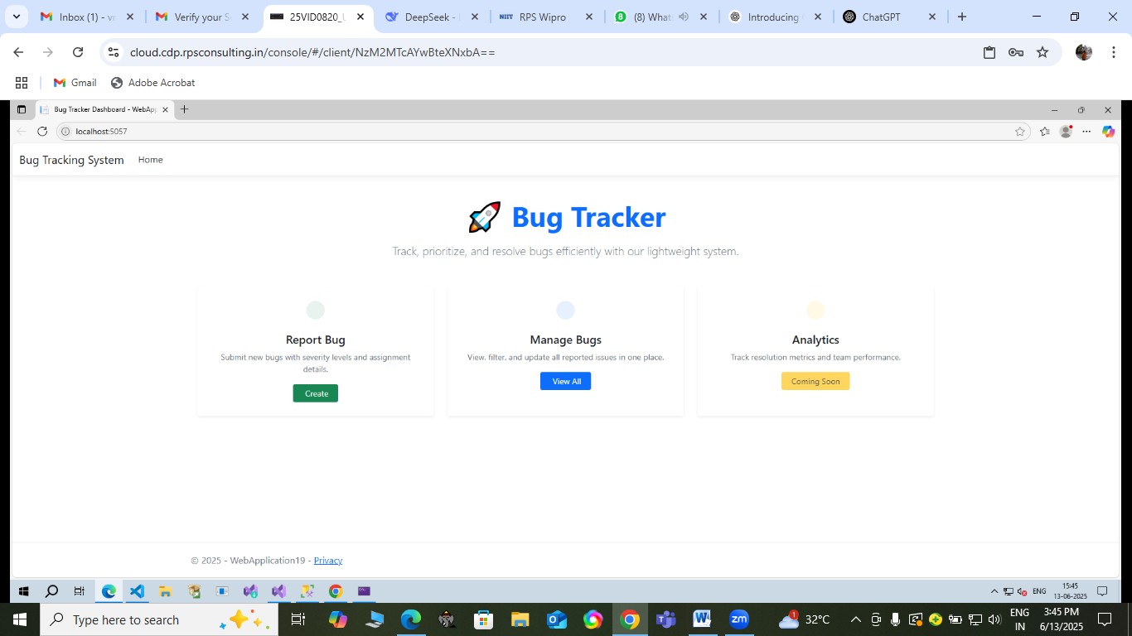

1. **After clicking on ViewAll , the Bug Lists will be displayed**

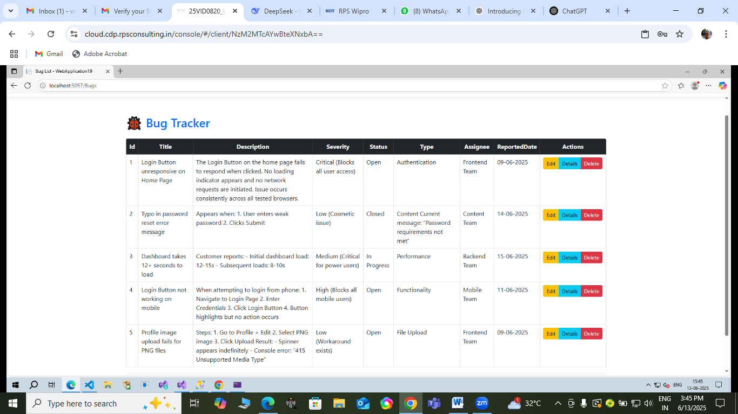

1. **Click on Delete Button to get Delete Form**

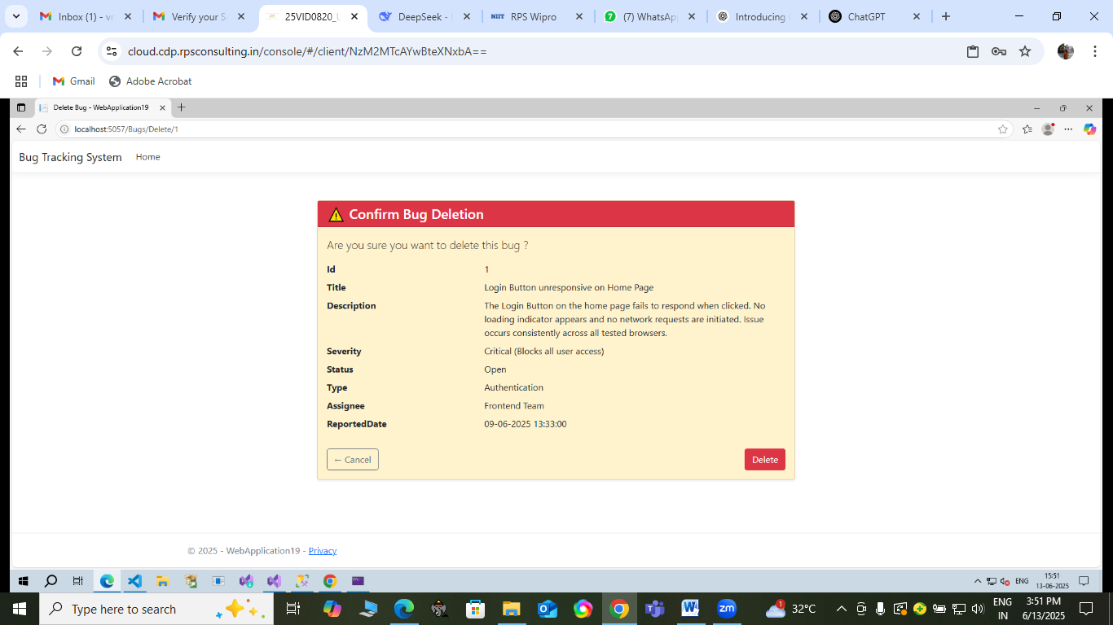

1. **Click on Details Button to get Details Form**

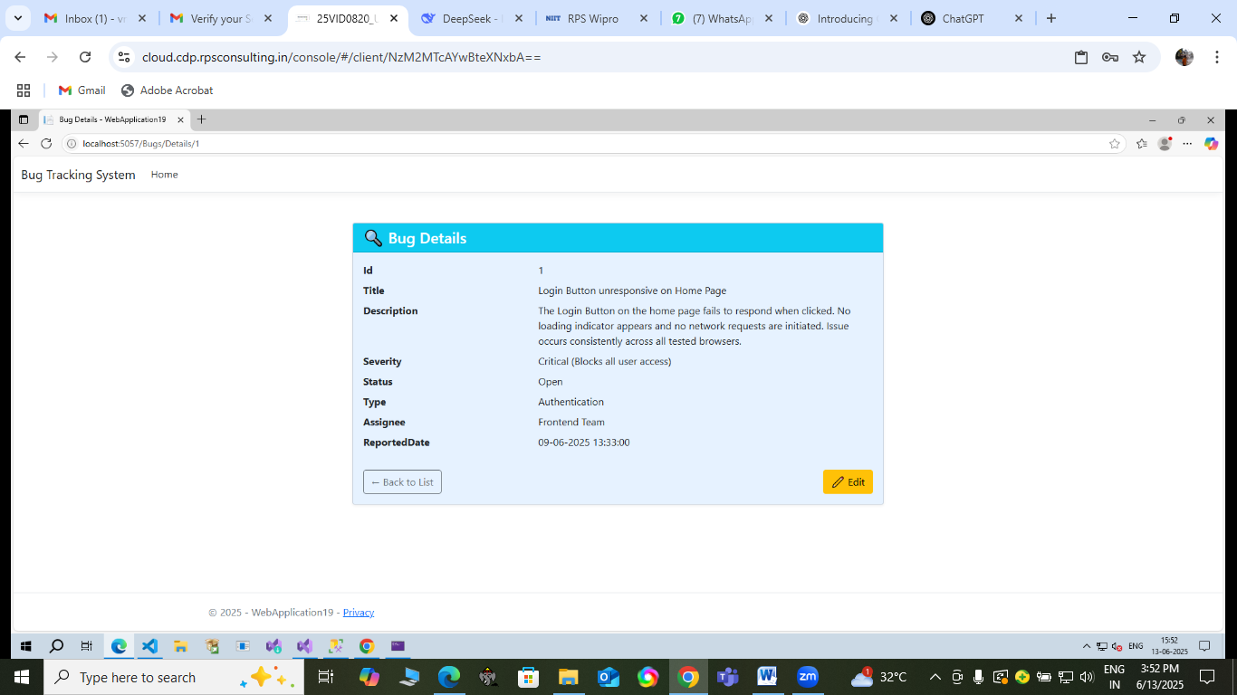

**3.Deployment steps :**

**Step 1: Create a new repository in GitHub as Capstone Project – Bug Tracking System keep it in public and Create repository**

**Step 2: Create a new Folder called as Capstone Project**

**Step 3: In Visual Studio Code(VS Code) Click on File → Open Folder and select the folder you have created**

**Step 4: Clone the repository using Git Clone URL Name → Enter**

**Step 5 : After Cloning, the repository name you have created will be display in the folder that you have created.**

**Step 6: Copy the codes from the Visual Studio and Paste it into VS code by clicking on new file and giving the file name.**

**Step 7: After you have Pushed all the codes to the VS Code click on Source Control give a name and click on Commit and Push.**

**Step 8: This whole Files and Folders you have created will be Pushed to GitHub**

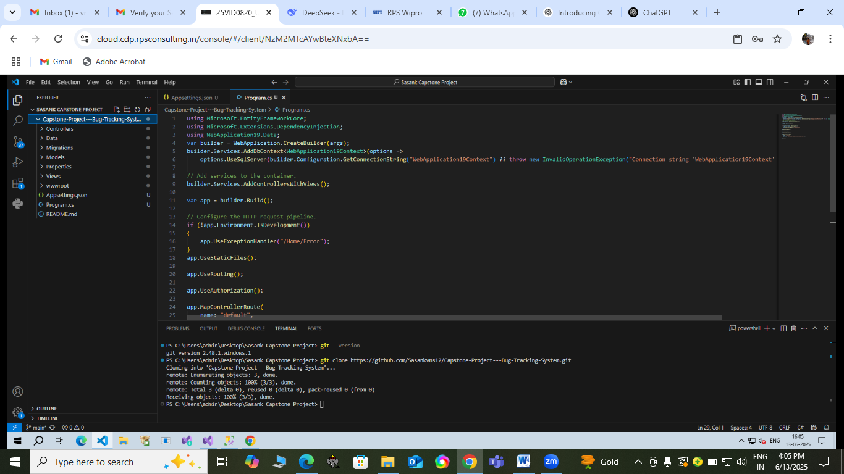

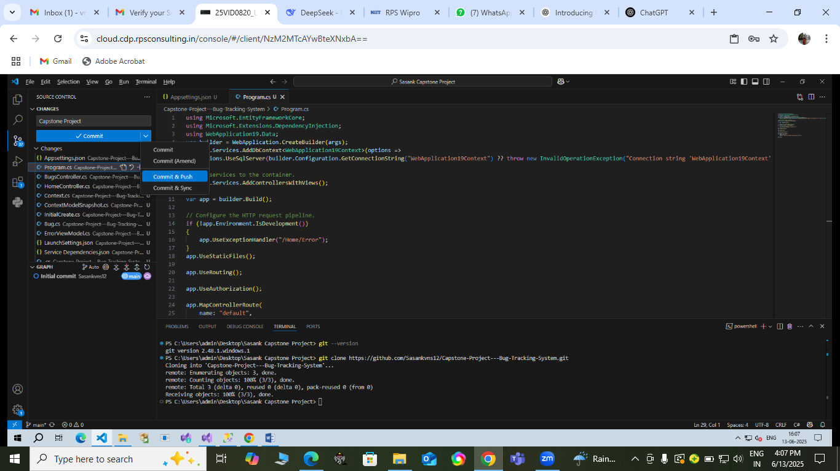

## ****Conclusion:****

**This ASP.NET MVC Bug Tracker provides:**

**✅  Structured MVC architecture  
✅  Database persistence with EF Core  
✅  CRUD operations for bugs  
✅ Easy customization & scaling**